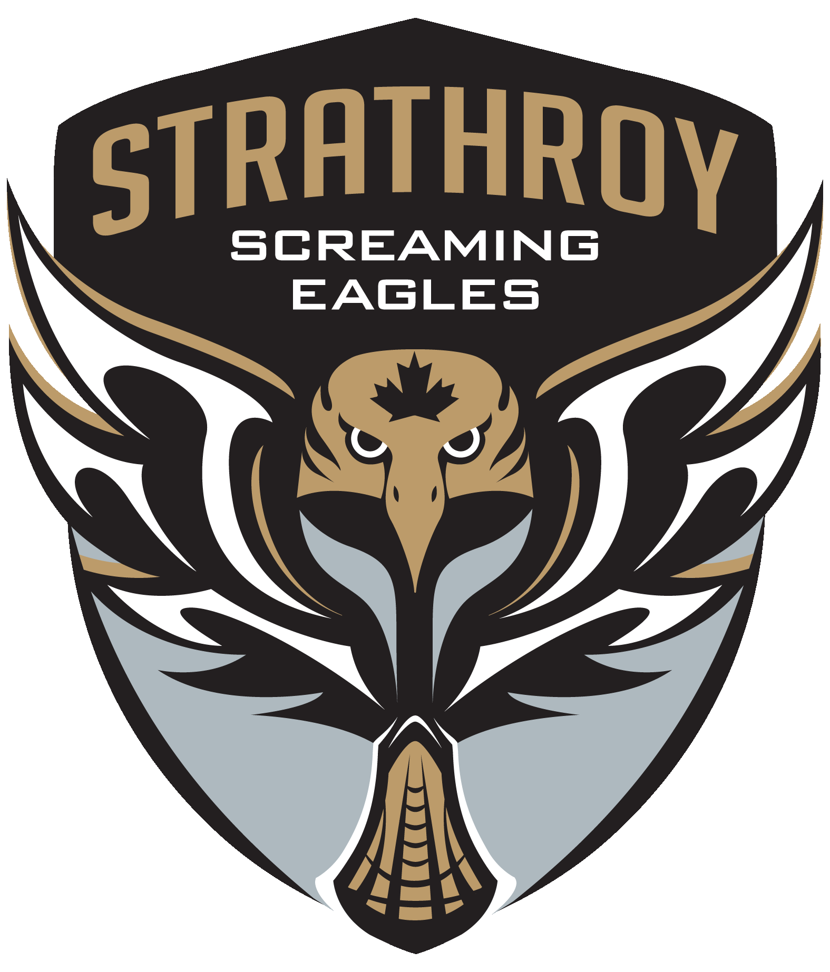
SMLA
Harassment, Bullying and Abuse Parent/Player Contract

- There will be zero tolerance for Harassment, Bullying or Abuse.
- This policy applies to all SMLA Volunteers, coaches, trainers, managers, parents/guardians, and players.
- Any allegations of Harassment, Bullying or Abuse will be investigated by either the affected teams’ Bench Staff and /or an appointed committee of Board Members.
- Depending on the severity of the Harassment, Bullying or Abuse, all incidents will be investigated and documented and may result in a verbal warning, suspension of players, release of players, Trespass Notices, or police involvement.

Definition of Harassment and Bullying

a) Harassment is defined as conduct, which is insulting, intimidating, humiliating, offensive or
physically harmful. Types of behaviour which constitute harassment include, but are not limited to:
- Unwelcomed jokes, innuendo or teasing about a person's looks, body, attire, age, race,
religion, sex or sexual orientation, including family members.
- Condescending, patronizing, threatening or punishing actions which undermine self esteem
or diminish performance.
- Practical jokes which cause awkwardness or embarrassment, endanger a person's safety
or negatively affect performance.
- Unwanted or unnecessary physical contact including touching, patting, or pinching.
- Any form of hazing.
- Any form of physical assault or abuse.
- Any sexual offence.
- Behaviours such as those described above which are not directed towards
Individuals or groups but which have the effect of creating a negative or hostile
Environment.

b) Bullying is defined as intentionally hurting someone to insult, humiliate, degrade
or exclude him or her. Basically, it is “mean” behaviour. Bullying is:
- hurting behaviours based on oppression and “meanness”
- based on power differentials
- intentionally harmful
- intense and long in duration
- repeated over time (generally)
- oppressive – isolates victims
- caused by many factors and behavioural challenges.

Hurtful actions may include but aren’t limited to:
i) Physical – ie: hitting, kicking, grabbing, shoving, spitting on, beating others up, damaging
or stealing another person’s property
ii) Verbal – ie: name-calling, humiliating, degrading behaviour, hurtful teasing, threatening
someone (this may happen in notes or in person, over the phone, through text messages
or a chat room, Facebook or Twitter)
iii) Relational – ie: making others look foolish, excluding peers, spreading gossip or rumours
(this may happen in person, over the phone or through the computer)

Parent/Guardian Name and Signature:__________________________________________________
Player Name and Signature:___________________________________________________________
Date:______________________________________________________________________________

